***St. Joseph’s Church, O’Connell Avenue, Limerick***

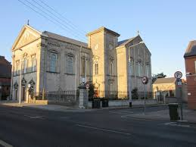

***Church Notices30th January 2022***

Sun 30th January ***10.30am*** – *Intention of Clergy*

***12.30pm*** –Darren O’Donovan *(6th Av)*

***12.30pm –*** Mairéad O’Loughlin *née* Hayes ***Drimeenagun, Broadford and formerly of the Glen, Killaloe, Co. Clare*** *who died recently*

***5.30pm*** – *Intention of Clergy*

*Please pray for the soul of John Harrison whose Anniversary occurs this week*

Mon 31st January ***10.30am*** *– Intention of Clergy*

Tues 1st February ***10.30am*** – John Harrison *(Av)*

Wed 2nd February ***10.30am*** – *Pro Populo*

Thurs 3rd February ***10.30am*** *– Intention of Clergy*

Fri 4th February ***10.30am –*** Marie Rocca *née* Enright *(Month’s Mind)*

***10.30am -*** Deceased Members of the Deegan Family & also John & Maria Murphy RIP

Sat 5th February ***10.30am*** – *Intention of Clergy*

Sun 6th February***10.30am*** –Larry & Pauline Hartnett

***12.30pm*** –Phil Skehan *(5th Av)*

***12.30pm*** –Frank O’Connor *(1st Av)*

***12.30pm*** –John McCarthy *(13th Av)*

***5.30pm*** – *Intention of Clergy*

**YEARLY DONATION BOX OF ENVELOPES**

The new box of envelopes for the coming year will be distributed in the coming weeks. If you would like to receive a box for your donation to St. Joseph’s Parish, please make contact with either Úna or Fr. Liam. Thank you

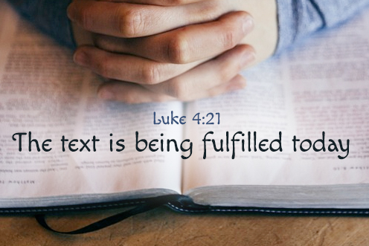

**IF YOU WOULD LIKE TO DONATE CANDLES TO ST JOSEPH’S CHURCH FOR USE ON THE SANCTUARY FOR THE COMING YEAR OR HAVE CANDLES BLESSED FOR USE IN YOUR HOME, PLEASE BEING THEM IN BEFORE TUESDAY 2ND FEBRUARY**

**CALLING NEW MINISTERS FOR OUR CHURCH**

We would like to invite you to consider becoming a Reader or Eucharistic Minister in our Parish Church. Please take time to consider volunteering just a little time in the service of the church and in the celebration of our liturgies. Training for Eucharistic ministers and readers is being organised in the near future so get in touch with Úna or Fr. Liam if you are interested. Thank you.

**LIVE-STREAMING**

We are now live-streaming our services from St. Joseph’s Church. All you need to do is to visit our parish website ***stjosephsparish.ie*** and click on the web-cam option. We would also ask you to please ***consider making a donation on line*** for the upkeep of our beautiful church.

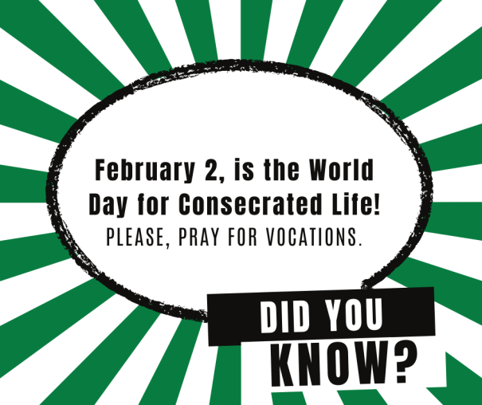

**FEAST OF THE PRESENTATION OF THE LORD.** On Tuesday the Church celebrates the feast of the **Presentation of the Lord** which occurs forty days after the birth of Jesus and is also known as Candlemas day, since the blessing and procession of candles is included in today's liturgy.Founded by Pope St. John Paul II in 1997, today is the World Day of Prayer for Consecrated Life. He attached it to "Candlemas Day" because the consecrated men and women are to be the light in the world, imitating Jesus, the Light of the World.

**FOLLOW THE FOOTSTEPS OF JESUS**

**FROM GALILEE TO JERUSALEM 2022**

**Take the TRIP of a LIFETIME to the HOLY LAND, 23rd May-2nd June 2022.**

**Group Leader, Mícheál de Barra and Spiritual Director, Fr. John Newman (Scripture Scholar). In association with Premier Travel, Cork**

**Contact Mícheál at 086-8337681 or email** [**info@carpediemtours.ie**](mailto:info@carpediemtours.ie)

**(See also our website:** [**www.carpediemtours.ie**](http://www.carpediemtours.ie)**)**

**We would continue to ask that parishioners and visitors would consider maintaining a sensible distance, in so much as one can, from each other. If you are feeling unwell, we would kindly ask that you remain at home until you are back to good health. We must also ask that everyone who attends St. Joseph’s Church must wear a mask until otherwise instructed. Thank you.**

|  |  |  |
| --- | --- | --- |
| |  |  | | --- | --- | | |  | | --- | |  | | |
| |  |  | | --- | --- | | |  | | --- | |  | | |

**Contact Details: Fr. Liam Enright 087-7415603, Sacristan: Úna McCarthy 061-313401**

***Email:***[*stjosephsparishlk@eircom.net*](mailto:stjosephsparishlk@eircom.net)***Website:*** *stjosephsparish.ie*